NCERT notes on important topics for the IAS aspirants. These notes will also be useful for other competitive exams like banking PO, SSC, state civil services exams and so on. This article talks about Post-Mauryan India – Sunga Dynasty.
After the death of Ashoka, the Mauryan Empire steadily disintegrated as his successors were not able to keep the vast empire from fracturing away. Independent kingdoms arose out of the provinces. Foreign invasions were occurring in the northwest. Kalinga declared its independence. In the South, the Satavahanas rose to power and in the Gangetic plains, Sunga or Shunga dynasty replaced the Mauryas.
Kickstart your UPSC 2022 preparation today!
Sunga Dynasty (UPSC Notes):-
To help ease the path of your IAS preparation, check out the Free NCERT Fundamentals Course– a comprehensive study program to help you cover the NCERTs effectively. Watch the video below to learn more:
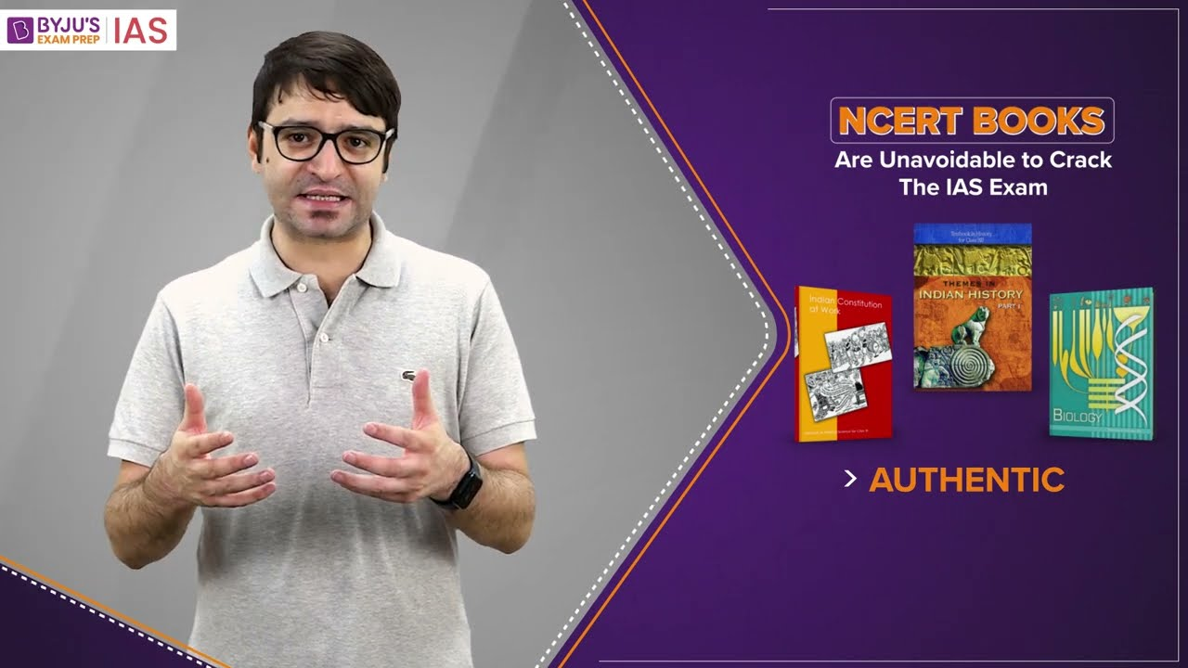
13,94,871
Pushyamitra Sunga
- Pushyamitra Sunga was Brahmin army chief of Brihadratha, the last king of the Mauryas.
- During a military parade, he killed Brihadratha and established himself on the throne in 185 or 186 BC.
- According to some historians, this was an internal revolt against the last Mauryan king. Some say it was a Brahminical reaction to the Mauryan overwhelming patronage of Buddhism.
- Pushyamitra Sunga’s capital was at Pataliputra.
- He successfully countered attacks from two Greek kings namely, Menander and Demetrius.
- He also thwarted an attack from the Kalinga king Kharavela.
- He conquered Vidarbha.
- He followed Brahminism. Some accounts portray him as a persecutor of Buddhists and a destroyer of stupas but there has been no authoritative evidence to this claim.
- During his reign, the Stupas at Sanchi and Barhut were renovated. He built the sculptured stone gateway at Sanchi.
- He performed Vedic sacrifices such as Ashvamedha, Rajasuya and Vajapeya.
- Pushyamitra Sunga patronised the Sanskrit grammarian Patanjali.
- According to the Puranas, his reign lasted for 36 years. He died in 151 BC.
Agnimitra
- Was Pushyamitra’s son who succeeded him to the throne.
- His reign lasted from about 149 BC to 141 BC.
- By this time, Vidarbha broke away from the empire.
- Agnimitra is the hero of Kalidasa’s poem, Malavikagnimitram.
- His son Vasumitra succeeded him as king.
Last of the Sunga kings
- Vasumitra’s successors are not clearly known. Different names crop up in several accounts such as Andhraka, Pulindaka, Vajramitra and Ghosha.
- The last Sunga king was Devabhuti. He was preceded by Bhagabhadra.
- Devabhuti was killed by his own minister, Vasudeva Kanva in around 73 BC. This established the Kanva dynasty at Magadha from 73 to 28 BC.
Effects of Sunga rule
- Hinduism was revived under the Sungas.
- The caste system was also revived with the rise of the Brahmanas.
- Another important development during the Sunga reign was the emergence of various mixed castes and the integration of foreigners into Indian society.
- The language of Sanskrit gained more prominence during this time. Even some Buddhist works of this time were composed in Sanskrit.
- The Sungas patronised art and architecture. There was an increase in the usage of human figures and symbols in art during this period.
Sunga Dynasty (UPSC Notes):-
Frequently Asked Questions about Sunga Dynasty
Q1
Who was the founder of the Sunga dynasty?
Sunga dynasty, was founded by Pushyamitra about 185 bc .It replaced the Mauryan dynasty.
Q2
What is the Sunga Dynasty known for?
The dynasty is noted for its numerous wars with both foreign and indigenous powers. They fought the Kalinga, the Satavahana dynasty, the Indo-Greek Kingdom and possibly the Panchalas and Mitras of Mathura.
Also Read | UPSC IAS Prelims Examination: Important Dynasties and kingdoms of Ancient India
UPSC Books List PDF:-Download PDF Here
UPSC Preparation
UPSC FAQ | UPSC Calendar 2022
UPSC Exam Pattern | UPSC Age Limit
UPSC Books | Daily News Analysis
UPSC Previous Year Question Papers | IAS Current Affairs
NCERT Notes For UPSC | Daily Video Analysis: The Hindu
Comments
Leave a Comment

Your Mobile number and Email id will not be published. Required fields are marked *
*
*
Post My Comment

Kanva dynasty had a Brahmanic origin. The dynasty was named after the gotra of the ruler Kanva. The Kanva dynasty was founded by Vasudeva Kanva. It is believed that Vasudeva Kanva killed the Shunga ruler Devabhuti and established his own empire in 72 BCE.
Kanva dynasty had a ruling phase from 72 BCE to 28 BCE.
The chronology of Shunga, Kanva dynasty and Satvahana dynasty is given below:
- Shunga dynasty
- Kanva dynasty
- Satvahana dynasty
This article throws light on the emergence of Kanva dynasty from the Shunga dynasty and other important aspects of the events that took place during the rule of the Kanva dynasty.
This is an important topic for UPSC 2023 exam and other government exams.
Get an edge over your competition in one of the toughest exams by visiting the UPSC Previous Year Question Papers page
Strengthen your preparation for the UPSC exam by checking the following links:
- Attempt the CSAT Mock Test
- Download UPSC Ancient Indian History Notes PDF (Free)
- Download UPSC Medieval Indian History Notes PDF (Free)
- Download UPSC Modern Indian History Notes PDF (Free)
- Download UPSC Notes PDF (Free)
- Take the IAS Mock Tests
Era of the Kanva Dynasty (UPSC Notes):-
Shunga dynasty
The Shunga dynasty formed a large part of Magadha and was founded by Pushyamitra Shunga after the fall of the Mauryan empire. There were 10 rulers who ruled India during the ancient period. Major cultural reforms took place during the reign which is evident from the coins and inscriptions retrieved by archaeologists.
An interesting thing to note about the Sunga dynasty was the emergence of various mixed castes and the integration of foreigners into Indian society.
The language of Sanskrit gained more prominence during the rule of the Shunga kings. Even some Buddhist works of this time were composed in Sanskrit.
The major rulers of the Shunga dynasty were – Pushyamitra Sunga, Agnimitra, Bhagabhadra, Devabhuti, etc.
To know more about the Shunga dynasty, check the linked article.
Kanva dynasty
This dynasty was founded by Vasudeva Kanva. He ruled for a short period and was succeeded by Bhumimitra. The empire was extended into parts of eastern India and central India. The Kanva dynasty had claimed Vidisa as their capital.
The major rulers during that phase were:
- Vasudeva Kanva
- Bhumimitra
- Narayana
- Susarman
Bhumimitra ruled for a period of 14 years and his son Narayana ruled for 12 years. The Satvahana dynasty defeated the Kanva dynasty and established their empire. The last Kanva king Susarman was killed by the Satavahana (Andhra) king.
Satvahana dynasty
The Satavahana rule is believed to have started around the third century BC, in 235 BC and lasted until the second century AD. Simuka was the founder of the Satvahana dynasty. Their capital cities varied at different times. Pratishthana (Paithan) and Amaravati were its capitals.
Some experts believe their rule started in the first century BC only. They are referred to as Andhras in the Puranas.
The Satavahana kingdom chiefly comprised of modern-day Andhra Pradesh, Telangana and Maharashtra. At times, their rule also included parts of Karnataka, Gujarat and Madhya Pradesh.
The major rulers of the Satvahana dynasty were – Satakarni, Hala, Gautamiputra Satakarni. The administration of the Satvahana era was purely based on the Shastras and their religious views were liberal.
To know more about the Satvahana dynasty, check the linked article.

Era of the Kanva Dynasty (UPSC Notes):-
Related Links:
NCERT Notes | Mauryan Empire
Magadha Empire | UPSC Books
UPSC Calendar 2023 | UPSC Prelims
Comments
Leave a Comment

Your Mobile number and Email id will not be published. Required fields are marked *
*
*
Post My Comment

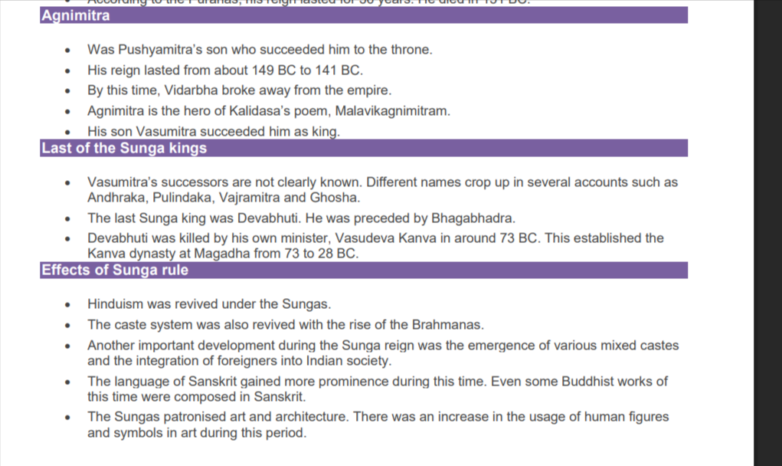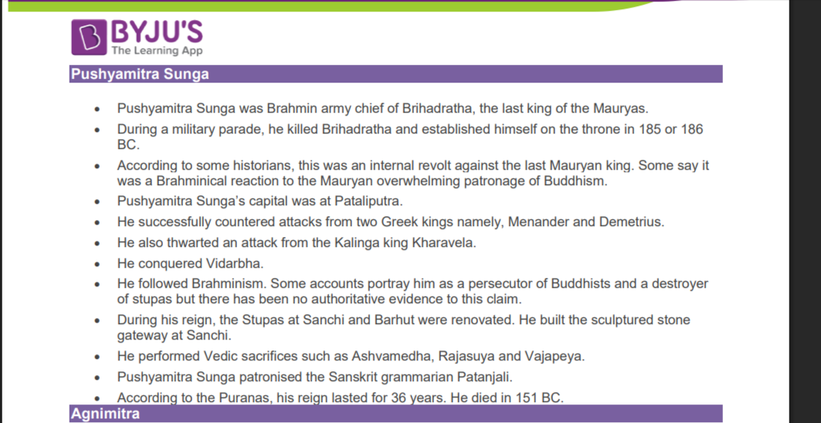

Kanva
Kanva dynasty had a Brahmanic origin. The dynasty was named after the gotra of the ruler Kanva. The Kanva dynasty was founded by Vasudeva Kanva. It is believed that Vasudeva Kanva killed the Shunga ruler Devabhuti and established his own empire in 72 BCE.
Kanva dynasty had a ruling phase from 72 BCE to 28 BCE.
The chronology of Shunga, Kanva dynasty and Satvahana dynasty is given below:
- Shunga dynasty
- Kanva dynasty
- Satvahana dynasty
This article throws light on the emergence of Kanva dynasty from the Shunga dynasty and other important aspects of the events that took place during the rule of the Kanva dynasty.
This is an important topic for UPSC 2023 exam and other government exams.
Get an edge over your competition in one of the toughest exams by visiting the UPSC Previous Year Question Papers page
Strengthen your preparation for the UPSC exam by checking the following links:
- Attempt the CSAT Mock Test
- Download UPSC Ancient Indian History Notes PDF (Free)
- Download UPSC Medieval Indian History Notes PDF (Free)
- Download UPSC Modern Indian History Notes PDF (Free)
- Download UPSC Notes PDF (Free)
- Take the IAS Mock Tests
Era of the Kanva Dynasty (UPSC Notes):-
Shunga dynasty
The Shunga dynasty formed a large part of Magadha and was founded by Pushyamitra Shunga after the fall of the Mauryan empire. There were 10 rulers who ruled India during the ancient period. Major cultural reforms took place during the reign which is evident from the coins and inscriptions retrieved by archaeologists.
An interesting thing to note about the Sunga dynasty was the emergence of various mixed castes and the integration of foreigners into Indian society.
The language of Sanskrit gained more prominence during the rule of the Shunga kings. Even some Buddhist works of this time were composed in Sanskrit.
The major rulers of the Shunga dynasty were – Pushyamitra Sunga, Agnimitra, Bhagabhadra, Devabhuti, etc.
To know more about the Shunga dynasty, check the linked article.
Kanva dynasty
This dynasty was founded by Vasudeva Kanva. He ruled for a short period and was succeeded by Bhumimitra. The empire was extended into parts of eastern India and central India. The Kanva dynasty had claimed Vidisa as their capital.
The major rulers during that phase were:
- Vasudeva Kanva
- Bhumimitra
- Narayana
- Susarman
Bhumimitra ruled for a period of 14 years and his son Narayana ruled for 12 years. The Satvahana dynasty defeated the Kanva dynasty and established their empire. The last Kanva king Susarman was killed by the Satavahana (Andhra) king.
Satvahana dynasty
The Satavahana rule is believed to have started around the third century BC, in 235 BC and lasted until the second century AD. Simuka was the founder of the Satvahana dynasty. Their capital cities varied at different times. Pratishthana (Paithan) and Amaravati were its capitals.
Some experts believe their rule started in the first century BC only. They are referred to as Andhras in the Puranas.
The Satavahana kingdom chiefly comprised of modern-day Andhra Pradesh, Telangana and Maharashtra. At times, their rule also included parts of Karnataka, Gujarat and Madhya Pradesh.
The major rulers of the Satvahana dynasty were – Satakarni, Hala, Gautamiputra Satakarni. The administration of the Satvahana era was purely based on the Shastras and their religious views were liberal.
To know more about the Satvahana dynasty, check the linked article.

Era of the Kanva Dynasty (UPSC Notes):-
Related Links:
NCERT Notes | Mauryan Empire
Magadha Empire | UPSC Books
UPSC Calendar 2023 | UPSC Prelims
Comments
Leave a Comment

Your Mobile number and Email id will not be published. Required fields are marked *
*
*
Post My Comment

Vaktakas
NCERT notes on important topics for the UPSC civil services exam. These notes will also be useful for other competitive exams like banking PO, SSC, state civil services exams and so on. This article talks about the Vakatakas of ancient India.
Kickstart your UPSC 2022 preparation today!
The Vakataka Dynasty (UPSC Notes):-
Vakataka Dynasty
The Satavahanas in peninsular India were succeeded by the Vakatakas (local power) who ruled the Deccan for more than two and a half centuries. The Vakatakas were the contemporaries of the Guptas in northern India. In the Puranas, the Vakatakas are referred to as the Vindhyakas. The Vakatakas belonged to the Vishnuvriddha gotra of the Brahmanas and performed numerous Vedic sacrifices. A large number of copperplate land grant charters issued by the Vakatakas to the Brahmans have helped in reconstructing their history. They were Brahmins and promoted Brahmanism, however, they also patronised Buddhism. Culturally, the Vakataka kingdom became a channel for transmitting Brahmanical ideas and social institutions to the south. The Vakatakas entered into matrimonial alliances with the Guptas, the Nagas of Padmavati, the Kadambas of Karnataka and the Vishnukundins of Andhra. The Vakatakas patronised art, culture and literature. Their legacy in terms of public works and monuments have made significant contributions to Indian culture.
Under the patronage of the Vakataka king, Harisena, the rock-cut Buddhist Viharas and Chaityas of the Ajanta caves (World Heritage Site) were built. Ajanta cave numbers ⅩⅥ, ⅩⅦ, ⅩⅨ are the best examples of Vakataka excellence in the field of painting, in particular the painting titled Mahabhinishkramana. Vakataka kings, Pravarasena Ⅱ (author of the Setubandhakavya) and Sarvasena (author of Harivijaya) were exemplary poets in Prakrit. During their rule, Vaidharbhariti was a style developed in Sanskrit which was praised by poets of the likes of Kalidasa, Dandin and Banabhatta.
Also read about the Gupta Empire in the linked article.
Origins
- The Vakatakas were Brahmins.
- Their origins are not clear with some claiming they are a northern family while others claim they originated in southern India.
- They have Sanskrit and Prakrit inscriptions which are similar to those belonging to the southern Pallavas.
- Also, no records of the Vakatakas have been found north of the Narmada. They are also mentioned in the Puranas.
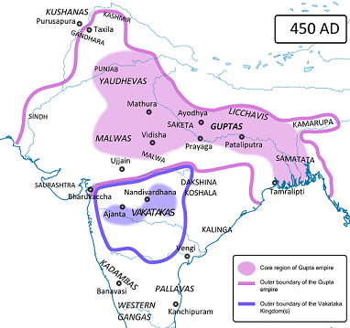
Extent
The Vakataka kingdom extended from the southern extremities of Malwa and Gujarat in the north to the Tungabhadra River in the south, and from the Arabian Sea in the west to the edges of Chhattisgarh in the east.
Rulers
Vindhyashakti (Reign: 250 – 270 CE)
- Founder of the dynasty.
- Probably ruled from Purika.
  - Performed a number of Vedic sacrifices and revived Brahmanical rituals.
- He is described as a Dvija on the Ajanta inscriptions of the time of Harisena and is praised for his military accomplishments.
Pravarasena I (Reign: 270 – 330 AD)
- Son and successor of Vindhyashakti.
- His other titles include Samrat, Dharmamaharaja and Haritiputra.
- His empire included a good portion of northern India and the Deccan.
- He conducted Vedic rituals like Ashwamedha, Vajapeya, etc.
- The founder of the real power and greatness of the Vakatakas. He enlarged his empire southwards into Vidarbha and adjoining areas of the Deccan, with his capital at Kanchanaka (modern Nachna).
- His son Gautamiputra married the daughter of the Naga king Bhavanaga, which formed an important political alliance.
- With the help of matrimonial alliances and military power, he extended his empire from Bundelkhand in the north to Hyderabad in the south. To celebrate his victories, he performed an asvamedha and a vajapeya sacrifice. He adopted the title “Samrat” while all other Vakataka kings took the title of “Maharaja”.
- He conducted wars with the Nagas.
- He had four sons as per the Puranas and it is possible that the empire split up among his sons.
- His son Gautamiputra died before him and his grandson (son of Gautamiputra) Rudrasena I succeeded him to the throne and ruled from Nandivardhana. Sarvasena, another son of Pravarasena, ruled independently from Vatsagulma.
- After his death, there were two divisions of the Vakatakas.
  - Pravarapura-Nandivardhana Branch [Nandivardhana – modern Nagpur]
  - Vatsagulma Branch [Modern Washim, Akola district, Maharashtra]
Pravarapura-Nandivardhana Branch
This branch ruled over Pravarapura (in present Wardha, Maharashtra), Mansar and Nandivardhan in the present Nagpur district.
Rudrasena I (Reign: 340 – 365 CE)
- Grandson of Pravarasena I.
- Founder of the Nandivardhana branch of the Vakataka kingdom.
- He was a worshipper of Lord Mahabhairava, the fierce form of Shiva.
Prithvisena Ⅰ (c. 365 – 390 CE)
- In Vakataka inscriptions, he was compared to the epic hero Yudhishthira due to his comparable qualities of truthfulness, compassion and humility.
- Padmapura was an important administrative centre during his reign.
- The political alliance with Chandragupta Ⅱ was an important feature of his reign and together they defeated the Shaka Satraps of Malwa and Kathiawar.
- Guptas and Vakatakas strengthened their bond by a marriage alliance between Rudrasena Ⅱ (Prithvisena’s son) and Prabhavatigupta (daughter of Chandragupta Ⅱ).
- Followed Shaivism like his father.
Rudrasena II (Reign: 390 – 395 CE)
- Son of Prithvisena I.
- Married Prabhavatigupta, daughter of Chandragupta II.
- He ruled for only five years leaving behind his three sons – Divakarasena, Damodarasena and Pravarasena. His wife Prabhavatigupta ruled as the regent until 410 CE. The seal of Prabhavatigupta’s Maregaon plates describes her as the ‘mother of two kings’ because her elder son Divakarasena did not live long enough to ascend the throne but both her younger sons did rule.
Pravarasena II (Reign: 395 – 440 CE)
- Was named Damodarasena.
- Second son of Rudrasena II.
- He became the king after his elder brother Diwakarasena died.
- A dozen copper plate grants of his were discovered in different parts of Vidarbha. The largest number of Vakataka inscriptions belong to his reign.
- Founded a new capital at Pravarapura (Paunar in the present-day Wardha district).
- He entered into a matrimonial alliance with the contemporary Kadambas (near Mysore).
- Composed Setubandha/Ravanavaha, a Prakrit (Maharashtri Prakrit) kavya glorifying Rama. It is about Rama’s journey to Lanka and his victory over Ravana.
- He was a devotee of Shiva.
Narendrasena (c. 440 – 460 CE)
- He was married to Ajihata Bhattarika, the daughter of Kakutsavarman of the Kadamba dynasty.
- He had to face stiff opposition from Nalas.
Prithvisena Ⅱ (c. 460 – 480 CE)
- Last known ruler of the Nandivardhana branch of the Vakataka dynasty.
- His inscriptions refer to his having twice rescued the sunken fortunes of Vakatakas.
- He had to face the invasion of Harisena of the Vatsagulma line thrice, and the invasion of Bhavadottavarman of the Nala dynasty. It appears that he had to fight with the Traikutaka king, Dahrasena of southern Gujarat as well.
- After his death, it is presumed that Harisena of the Vatsagulma branch of the Vakatakas conquered his successors and united the Nandivardhana branch with his own.
Vatsagulma Branch
This branch ruled over the territory between the Sahyadri Range and the Godavari River with its capital at Vatsagulma (present Washim, Maharashtra). Its founder was Sarvasena, the son of Pravarasena Ⅰ.
Sarvasena (Reign: 330 – 355 CE)
- Son of Pravarasena I.
- A renowned Prakrit poet, the author of Harivijaya. Some of his verses were incorporated into the Gathasattasai.
- He adopted the title “Dharma-Maharaja”.
Vindyashakti Ⅱ/Vindhyasena (c. 355 – 400 CE)
- His kingdom included the Marathwada region (southern part of Vidarbha), the northern part of Hyderabad and some other adjoining territories. He ruled for about four decades.
- It appears that he had defeated the Kadambas of Banavasi who ruled over Kuntala (North Karnataka).
- His son and successor Pravarasena Ⅱ ruled for about fifteen years. Pravarasena Ⅱ was succeeded by Devasena, who was a pleasure-seeking ruler but was lucky enough to have a capable minister in his kingdom – Hasthibhoja. His successor was the ablest and great ruler of the Vatsagulma branch.
Harisena (Reign: 475 – 500 AD)
- Fifth-generation descendent of Sarvasena.
- Patronised Buddhist art and architecture.
- Many of the Buddhist caves, Viharas and Chaityas at Ajanta were executed under his reign. Ajanta is a UNESCO World Heritage Site since 1983.
- The later caves at Ajanta show the high perfection and sophistication in art achieved under the Vakataka kings particularly Harisena.
- He united the two Vakataka branches and conquered Kuntala, Avanti, Kosala, Kalinga, Konkan and Andhra. His empire extended from Malwa in the north to southern Maharashtra in the south and from the Bay of Bengal in the east to the Arabian Sea in the west.
- Harisena is described as “powerful, truthful and bountiful, glorious, lofty and a penetrating critic of ethical and economic compendia” by Dandin, a poet of the 6th century CE.
- The Thalner copper plates belong to his reign and many of the Ajanta caves were executed during his reign.
- In one of his inscriptions, Varahadeva is mentioned as his minister.
- After his death, he was probably succeeded by a few rulers but not much is known about the end of the dynasty.
With the death of Harisena, the rule of the Vakatakas ended and the Nalas, the Kadambas, the Kalachuris and Yashodharman of Malwa occupied their territory.
The Vakataka Dynasty (UPSC Notes):-
Also Read:
UPSC Notes: Mauryan Empire
NCERT Notes: Pallavas
NCERT Notes: Chalukya Dynasty
UPSC Preparation
UPSC Prelims 2022 | UPSC Mains
UPSC Exam Pattern | IAS Exam
UPSC Books | Daily News Analysis
UPSC Previous Year Question Papers | IAS Current Affairs
NCERT Notes For UPSC | Daily Video Analysis: The Hindu
Comments
Leave a Comment

Your Mobile number and Email id will not be published. Required fields are marked *
*
*
Post My Comment

Deccan kingdom

Deccan Kingdoms has great importance in the Medieval History of India. This article extensively covers details on various Deccan Kingdoms and some of their important contributions. This article throws light on the Deccan Kingdoms starting from Chalukyas of the 6th Century A.D and other important Deccan Kingdoms like Hoysalas, Kakatiyas etc.
Aspirants would find this article very helpful while preparing for the IAS Exam.
The Deccan Kingdoms (UPSC Notes):-
Aspirants should begin their preparation by solving UPSC Previous Year Question Papers now!!
To complement your preparation for the upcoming exam, check the following links:
- Daily Video Analysis – The Hindu Newspaper
- Daily Press Information Bureau (PIB) Analysis
- Download NCERT Notes PDF (Free) for UPSC Exam
- Download Medieval History Notes PDF (Free) for IAS Exam
- Download Modern Indian History Notes PDF (Free)
Kingdoms of the Deccan
- The Deccan or the Dakshinapatha regions are the part of Southern India.
- The Vindhya and Satpura mountains, the Narmada and Tapti rivers, and the dense forests separate the Deccan from Northern India.
- The Deccan part witnessed the rise of the Chalukyas and the Rashtrakutas during the medieval period.
- This period also witnessed the expansion of the Delhi Sultanate like the Khiljis and the Tughluqs into South India.
Chalukyas (6th -12th century A.D.)
The Chalukyas period can be broadly divided into three and they are:
- The Early Western Chalukyas (6th-8th century A.D.)
- The Later Western Chalukyas (10th-12th century A.D.)
- The Eastern Chalukyas (7th-12th century A.D.)
Early Western Chalukyas (6th – 8th Century A.D.)
- They rose into power in the 6th century A.D in Karnataka.
- Vatapi (modern Badami) in the Bijapur district was their capital.
- Jayasimha and Ramaraya, Pulakesin-I (543-566.A.D) were humble rulers of the early Western Chalukyas.
Pulakesin II (610-642 A.D.)
- Pulakesin II is the real founder and greatest ruler of this dynasty
- He defeated Gangas, Malavas and Gurjaras.
- In 637 A.D he defeated Harsha’s attack in the north.
- He struggled constantly with the Pallavas in the south.
- Pulakesin II defeated the Pallava King Mahendravarma I after which he crossed the Cauvery.
- Made friendly alliances with the Cholas, Cheras and Pandyas.
- Pulakesin II lost his life during the war.
Other Important Rulers of this Dynasty
- Vikramaditya-I
- Vijayaditya
- Vikramaditya II
Kirtivarman II (746 AD – 753 AD)
- He is the last Chalukya King of Badami.
Later Western Chalukyas of Kalyani (10th – 12th century A.D)
The founder of this dynasty brought the Rashtrakuta rule to an end.
Important Rulers of this Dynasty
- Someshwara-II
- Vikramaditya-VI
- Vikramaditya-VI
- Someswara IV was the last ruler
Eastern Chalukyas of Vengi (7th – 12th century A.D)
- Vishnu Vardhana brother of Pulakesin-II was the founder of the Eastern Chalukya Empire of Vengi.
- Kulothunga Chola (1071-1122 A.D.) is one of their descendants.
- He was crowned as a Chola ruler.
Contributions of the Chalukyas
- They followed Hinduism.
- Ravikirti a Jain, the court poet of Pulakesin-II composed the Aihole Inscription.
- Great patrons of architecture
- 70 Vishnu temples in Aihole were built; hence Aihole has been called the ‘Cradle of Indian Temple architecture.
- Virupaksha temple at Pattadakal
- Telugu literature developed during this period.
The Virupaksha Temple
- Lokamahadevi built this temple and she was the queen of Vikramaditya II.
- In front of the Hall of the Priests or Antarala, there is a pillared Mandapam or a meeting place for the people.
- The Virupaksha temple is built on the model of the Kailasanatha temple at Kancheepuram.
Rashtrakutas (8th – 10th century A.D.)
Hoysalas of Dwarasamudra (11th -14th Century A.D.)
Vinayaditya (1006 -1022 A.D.)
- Vinayaditya carved out a trivial territory of Mysore with Sosavir as capital and ruled over it.
Vishnuvardhana (1108–1152 A.D.)
- He was the first distinguished ruler of Vinayaditya’s family.
- He shifted his capital to Dwarasamudra.
- He captured Gangavadi from Kulothunga Chola and Gangavadi served as a buffer state between the Chalukyas and the Chola Empire.
Vira Ballala – II (1173-1220 A.D.)
- Vira Ballala – II the next important ruler of the dynasty.
- He defeated Billama V of Yadava Dynasty.
- He detained the independence of the Hoysalas.
Narasimhan-II (1220-1235 A.D.)
- Narasimhan-II lost the territory between Krishna and Tungabhadra to a Yadava ruler, Singhana.
- He defeated Maravarman Sundara Pandya
- Restored Rajaraja-III to the Chola throne.
- He erected the pillar of victory at Rameshwaram.
Ballala III (1291-1342 A.D)
- Ballala III was the last great ruler of this dynasty.
- In 1310A.D. he was defeated by Malik Kafur.
- In 1342 A.D. he fell victim to the Sultans of Madurai.
Ballala IV
- His son Ballala IV continued his struggle with the Muslims.
- With his death, the Hoysala Kingdom came to end.
Contributions
- The Hoysalas paved the way for the rise of Mysore into a big Kingdom.
- They were great patrons of art, architecture and literature.
- The Hoysalas encouraged Kannada literature.
Kakatiyas of Warangal (12th -14th Century A.D.)
Prola-II (1110 -1158 A.D.)
- The Kakatiya ruler captured the territory between the Krishna and the Godavari from the Chalukyas and ruled over it with Hanumakonda as his capital.
Prataparudra-I (1158 – 1196 .A.D.)
- He was the son of Prola II who shifted the capital to Warangal.
Ganapathi (1199-1261. A.D.)
- He was the next remarkable ruler of this dynasty.
- He captured territories up to Kanchi from the Cholas.
- He invaded Kalinga and Western Andhra.
(Rudrambha) (1261 -1291 .A.D.)
- She was the daughter of Ganapati.
- She abdicated the throne in favour of her grandson Prataparudhra-II
Prataparudhra-II (1291-1326 A.D.)
- Malik Kafur invaded Warangal in 1309 A.D, during his rule.
- Prataprudra – II paid Malik Kafur an immense treasure in return.
Ulugh Khan
- Ulugh Khan, the son of Ghiasud-din Tughluq captured Warangal in 1323 A.D. and sent Prataparudra II to Delhi
- His successors continued their struggle with the rulers of the Tughluq dynasty
Vinayakadeva
- He is the last nominal ruler of this dynasty.
- He was sentenced to death by Muhammad Shah I.
KOHINOOR (the Famous Diamond belonged to Kakatiyas)
- KOHINOOR unearthed in Kollur on the banks of the Krishna River belonged to the Kakatiyas.
Contributions
- The Kakatiyas encouraged literature, art and architecture.
- The thousand Pillar temple at Hanumakonda was built during their period and stands as an everlasting contribution.
Yadavas of Devagiri (850–1334 A.D.)
- The Yadavas of Devagiri claimed their descent from the epic hero Lord Krishna.
- They were known as Sevunas because they ruled over Sevuna, the region from Nasik to Devagiri (Daulatabad).
Bhillama V (1175 – 1190 A.D.)
- The Yadava ruler took advantage of the declining power of the Later Western Chalukyas of Kalyani and rose to power.
- He defeated Someswara-IV and declared his independence.
- He came into conflict with Vira Balalla-II (1173-1220A.D.), a Hoysala ruler.
- He lost his life in the battle of Lakkundi.
Jaitrapala (1191-1210 A.D.)
- He was the son of Bhillama V
- He defeated Kalachuris, Gurjaras and Kakatiyas.
Singhana (1210-1247A.D.)
- He was the son of Jaitrapala.
- He was the most distinguished ruler of this dynasty.
- He defeated Mahadeva, a Kakatiya ruler.
- He also defeated Vira Ballala-II, the Hoysala ruler and expanded his dominion beyond the River Krishna.
- He invaded Gujarat many times and captured Kolhapur which belonged to Silhara dynasty.
Krishna (1247-1260 A. D)
- Krishna was the grandson of Singhana and succeeded him.
Mahadeva (1260-1271 A.D)
- He was brother Krishna.
- He captured North Konkan and ended the Silhara dynasty.
Ramachandra Deva (1271-1 309 A.D.)
- He was the last great ruler of this dynasty.
- Ala-ud-din-Khilji defeated him and made him as a vassal of the Delhi Sultanate.
Sankara Deva (1309 – 1312 A.D.)
- He was the son and successor of Ramachandra Deva
- Malik Kafur defeated and killed him in 1312 A.D.
- Harapala, brother-in-law of Sankara Deva raised the flag against the Khiljis.
- Mubarak, son of Ala-ud-din Khilji defeated and killed Harapala. Thus the Yadava dynasty came to an end.
Contribution of the Yadavas
Devagiri Fort
- Built during the reign of the Yadavas.
- It was one of the strongest forts in India.
- The Juma Masjid and Chand Minar were added by the Delhi Sultans later.
End of the Deccan Kingdoms
- The attacks on the Deccan Kingdoms by the Sultans of Delhi ever since the rule of Alauddin Khilji led to their decline.
Multiple Choice Question (MCQ)
Consider the Following Statements
- The Vindhya and Satpura mountains, the Narmada and Tapti rivers, and the dense forests separate the Deccan from Northern India.
- Pulakesin II defeated the Pallava King Mahendravarma I after which he crossed the Cauvery
- Vishnu Vardhana brother of Pulakesin-II was the founder of the Eastern Chalukya Empire of Vengi.
- Ravikirti a Jain, the court poet of Pulakesin-II composed the Aihole Inscription.
Which of the following statements is True?
A) None of the statements are true.
B) All the 4 statements are True.
C) Only 1 and 3 are true.
D) Only 3 and 4 are true.
Answer: B
The Deccan Kingdoms (UPSC Notes):-
Also Read:
The Vijayanagara Empire
The Bahamani Kingdom
The Bhakti Movement
The above details would help candidates prepare for UPSC 2023.
Related Links
IAS Salary | Static GK
Indian National Congress Sessions | Present Attorney General of India
Indian Revenue Service (IRS) | BYJU’S CNA
MPSC Exam | KPSC KAS
Comments

